SIMATS ENGINEERING
ASSESSMENT TOOL III — TIME-SERIES & GEOSPATIAL ANALYSIS REPORT
Course: Data Handling and Visualization | Code: DSA06031 | CO: CO4
Duration: 60 min | Total Marks: 50 | Reg No: 192424322  Name: M.Arshini

COURSE OUTCOME COVERED
Apply appropriate visualization techniques to analyze time series data, detect trends, seasonality, and cyclical patterns. (BL3)
CO3 Construct and interpret geospatial visualizations, including static, cartogram-based, and interactive representations. (BL3)
Activity Tool : Time-Series & Geospatial Analysis Report Weightage: 20%

Code of Conduct:
I M.Arshini (192424322) certify that this submission is my original work and that I have adhered to the guidelines specified for this assessment. I understand that any violation of academic integrity rules will result in disciplinary action.
Signature of the student: M.ARSHINI

Criteri a | Data Understandi ng & Preparation 25% | Time Series/Geospati al Analysis 25% | Applicati on of Visualizati on Techniques 20% | Report Organizati on 15% | Accura cy 10% | Clarity 5% | Total
Q1
Q2
Q3
Q4
Q5

Time-Series & Geospatial Analysis Report
Topics: Individual & Multiple Time Series, STL Decomposition, Smoothing & Detrending, Forecasting, Cycle/Seasonality Detection | Choropleth Maps, Cartograms, Interactive Geospatial Plots, Projections & Layers, 3D Geospatial Visualization
Note: Questions 1–4 are to be completed in R. Question 5 must be completed in Python.

Provided Datasets
The following files are supplied alongside this document. All are real, publicly documented datasets: ● Nile.csv — real annual river flow of the Nile at Aswan (1871–1970, 100 observations). ● AirPassengers.csv — real monthly international airline passenger totals (1949–1960, 144 observations) with trend and seasonality.
- USArrests.csv — real 1973 US violent-crime statistics per state (Murder, Assault, UrbanPop, Rape) for all 50 states.
- state_x77.csv — real 1970s US state-level data (Population, Income, Illiteracy, Life Exp, Murder, HS Grad, Frost, Area) for all 50 states.
- quakes.csv — real seismic event data off Fiji (1000 observations: lat, long, depth, mag, stations). ● volcano_elevation.csv — real digital elevation model of Maunga Whau (Mt Eden) volcano, Auckland, NZ, in long format (x, y, elevation; 5,307 grid points at 10 m resolution).
Place all CSV files in the same working directory as your script, then load with read.csv() in R or pandas.read_csv() in Python.

QUESTION 1: Individual Time Series — Smoothing & Detrending

Dataset provided: Nile.csv
Convert the value column into an R ts object (start = 1871, frequency = 1) and plot the raw annual flow as a line chart. Overlay a 5-year moving-average smoother. Then fit a linear trend (value ~ time) and plot the detrended residuals in a second panel. Discuss what the smoothed series and residual plot reveal about a level shift or change point in the data.
Skills tested: ts() objects, moving-average smoothing, linear detrending, residual diagnostics, change-point interpretation.

Aim
To smooth the Nile river-flow series, remove its linear trend, and identify a possible change point.
R Code
data<-read.csv("Nile.csv") value<-data$value
nile_ts<-ts(value,start=1871,frequency=1) moving_avg<-stats::filter(nile_ts,
filter=rep(1/5,5), sides=2)

time_nile<-time(nile_ts)

trend_model<-lm(as.numeric(nile_ts)~time_nile) detrended<-residuals(trend_model)
par(mfrow=c(2,1)) plot(nile_ts,type="l",
main="Nile River Flow with 5-Year Moving Average", xlab="Year",ylab="Flow")
lines(time_nile,moving_avg,lwd=2) plot(time_nile,detrended,type="l",
main="Detrended Nile River Flow",
xlab="Year",ylab="Residuals") abline(h=0,lty=2)
par(mfrow=c(1,1))

Interpretation
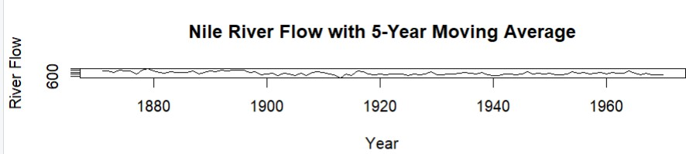
The moving average reduces short-term fluctuations and shows the underlying flow pattern more clearly. The smoothed series and residuals indicate a noticeable level shift around the late 1890s, with the later period generally having lower flow.

Result
The Nile series was successfully smoothed and detrended. The analysis indicates evidence of a change in the average river-flow level around the late 1890s.

QUESTION 2: Seasonal Decomposition — STL & Forecasting
Language: R
Dataset provided: AirPassengers.csv
Convert the passengers column into a ts object (start = c(1949,1), frequency = 12). Apply STL decomposition using s.window = "periodic" and plot the trend, seasonal and remainder components. State whether an additive or multiplicative decomposition suits this series better. Then fit an ETS or auto.arima() model and produce a 24-month-ahead forecast with prediction intervals. Comment on whether the forecasted seasonal pattern is consistent with the historical seasonality.

Aim
To identify trend and seasonality in airline passenger data and forecast future passenger numbers.

R Code
library(forecast)
data<-read.csv("AirPassengers.csv") passengers_ts<-ts(data$passengers,
start=c(1949,1), frequency=12)
stl_model<-stl(passengers_ts,
s.window="periodic") plot(stl_model)
model<-auto.arima(passengers_ts,
seasonal=TRUE) forecast_result<-forecast(model,h=24)
plot(forecast_result,
main="24-Month Passenger Forecast", xlab="Year",
ylab="Passengers")

Interpretation
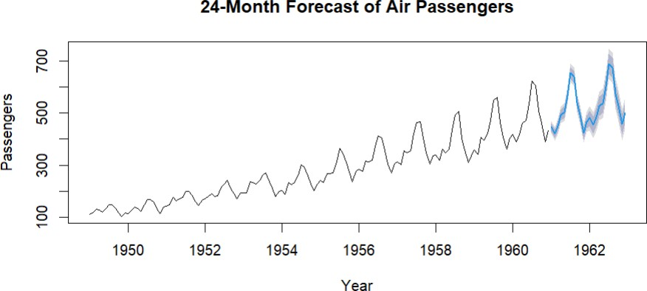
The STL decomposition shows a clear upward trend and strong yearly seasonality. Seasonal

fluctuations become larger as passenger numbers increase, so a multiplicative decomposition is more suitable.
The 24-month forecast continues the increasing trend and repeating seasonal pattern.

Result
STL successfully decomposed the series, and auto.arima() produced a 24-month forecast with prediction intervals.
QUESTION 3: Choropleth Map & Interactive Geospatial Plot

Part A — Choropleth Map Question
Language: R
Dataset provided: USArrests.csv
Join USArrests.csv to US state boundary polygons and create a choropleth map of Murder rate by state using a sequential color scale. Add a legend, title and caption. Identify the state(s) with the highest murder rate and describe any regional clustering.

Aim
To visualize the geographical distribution of murder rates across US states.
R Code library(ggplot2) library(dplyr) library(maps)

data<-read.csv("USArrests.csv", row.names=1)
data$state<-tolower(rownames(data)) states<-map_data("state")
map_data_final<-states%>% left_join(data,by=c("region"="state"))
ggplot(map_data_final, aes(long,lat,group=group,fill=Murder))+
geom_polygon(color="white")+ coord_fixed(1.3)+ scale_fill_gradient(low="lightyellow",
high="darkred")+ labs(title="Murder Rate by U.S. State",
fill="Murder Rate", caption="Source: USArrests")+
theme_minimal()

Interpretation
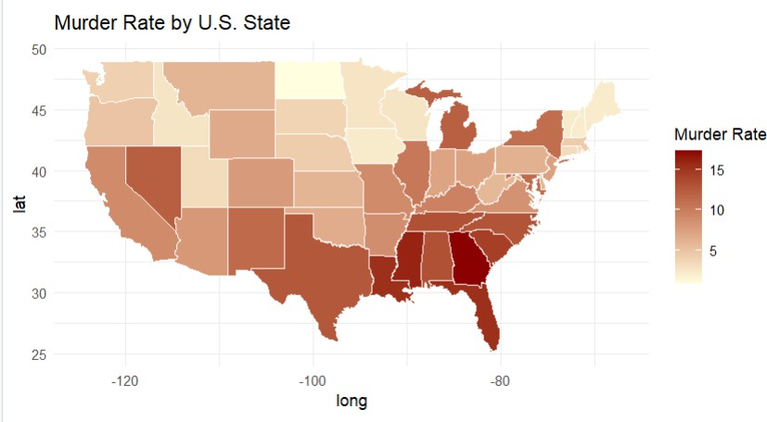
The map shows considerable variation in murder rates between states. Several relatively high values are concentrated in the Southern region.

Result
A choropleth map was successfully created to show state-wise murder rates.
Part B — Interactive Geospatial PlotQuestion

Language: R
Dataset provided: quakes.csv
Using the leaflet package, plot earthquake locations as circle markers, sizing each marker by magnitude and coloring by depth. Add popups showing magnitude and depth. Briefly describe any spatial clustering of high-magnitude events.

Aim
To visualize earthquake locations, magnitude and depth using an interactive map.

R Code
library(leaflet)

quakes<-read.csv("quakes.csv")
depth_palette<-colorNumeric( palette="YlOrRd", domain=quakes$depth
)

leaflet(quakes)%>% addTiles()%>% addCircleMarkers( lng=~long, lat=~lat, radius=~mag*2,
color=~depth_palette(depth), stroke=FALSE, fillOpacity=0.7, popup=~paste( "<b>Magnitude:</b>",mag, "<br><b>Depth:</b>",depth

)
)%>%
addLegend( pal=depth_palette, values=~depth, title="Depth"
)

Interpretation
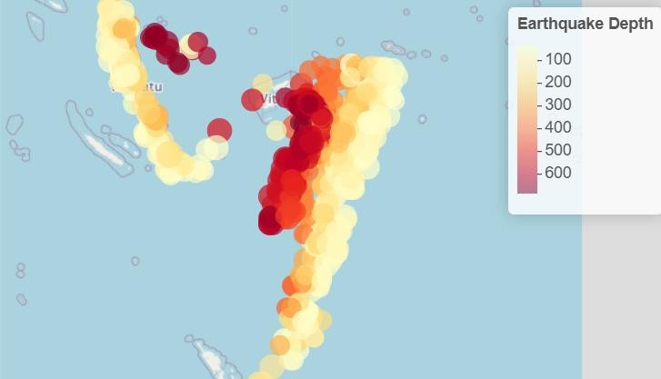
The earthquake points show spatial clustering in the study region. Larger circles identify higher-magnitude earthquakes, while color represents depth.

Result
An interactive Leaflet earthquake map was successfully created with marker sizing, depth coloring and popups.

QUESTION 4: Cartogram with Map ProjectionsQuestion
Dataset provided: state_x77.csv
Join state_x77.csv to US state boundary polygons and construct a population-weighted cartogram using the cartogram package. Render the cartogram alongside a standard choropleth of Population, using two different projections. Discuss how the cartogram changes the visual impression of state size and how projection affects the standard map's shape.

Aim
To compare a normal population map with a population-weighted cartogram and understand the effect of map projections.
R Code library(sf) library(ggplot2) library(dplyr) library(cartogram)
library(USAboundaries)

data<-read.csv("state_x77.csv") data$state<-tolower(rownames(data)) us_states<-us_states(map_date="latest") us_states$state<-tolower(us_states$name)

states_joined<-us_states%>% left_join(data,by="state")

population_cartogram<-cartogram_cont( states_joined,
weight="Population", itermax=10
)
ggplot(states_joined)+ geom_sf(aes(fill=Population))+ scale_fill_viridis_c()+ coord_sf(crs=4326)+
labs(title="Population Map - Longitude/Latitude")+ theme_minimal()
ggplot(states_joined)+ geom_sf(aes(fill=Population))+ scale_fill_viridis_c()+ coord_sf(crs=5070)+
labs(title="Population Map - Albers Projection")+ theme_minimal()
ggplot(population_cartogram)+ geom_sf(aes(fill=Population))+ scale_fill_viridis_c()+
labs(title="Population-Weighted Cartogram")+ theme_minimal()

Interpretation
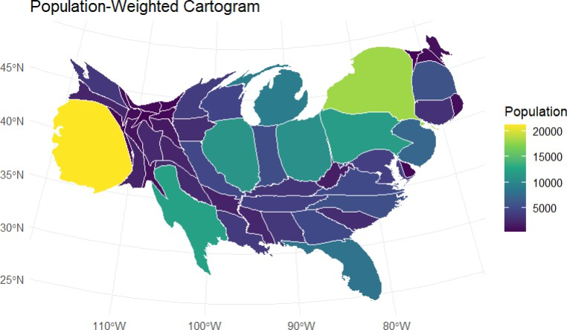
In a normal map, states retain their actual geographical size. In a cartogram, states with larger populations become visually larger, while less populated states become smaller.
The Albers equal-area projection provides a different shape representation from a simple longitude/latitude projection and is more suitable when comparing geographic areas.

Result
The cartogram successfully represents population concentration through distorted state areas,

while the standard maps preserve geographic representation.

QUESTION 5: 3D Geospatial Heatmap Dataset provided: volcano_elevation.csv
Load volcano_elevation.csv, pivot the data into a 2D elevation grid and create an interactive 3D surface heatmap using Plotly. Add axis titles and a title, and enable hover tooltips showing elevation at each grid point. Additionally produce a 2D top-down heatmap of the same data for comparison. Discuss what the 3D surface view reveals about the volcano's shape that the 2D heatmap alone does not.

Aim
To visualize the elevation and terrain structure of the volcano using 3D and 2D heatmaps.

Python Code
import pandas as pd
import plotly.graph_objects as go import matplotlib.pyplot as plt
df=pd.read_csv("volcano_elevation.csv") grid=df.pivot(index="y",
columns="x", values="elevation")

fig=go.Figure( data=[
go.Surface( z=grid.values, x=grid.columns, y=grid.index, colorscale="Earth", hovertemplate= "X: %{x}<br>"+
"Y: %{y}<br>"+
"Elevation: %{z}<extra></extra>"
)
]
)

fig.update_layout(
title="3D Surface Heatmap of Maunga Whau Volcano", scene=dict(
xaxis_title="X", yaxis_title="Y", zaxis_title="Elevation"
)
)

fig.show()
plt.figure(figsize=(10,7)) plt.imshow(
grid.values, origin="lower", aspect="auto"
)
plt.colorbar(label="Elevation") plt.title("2D Elevation Heatmap") plt.xlabel("X")
plt.ylabel("Y")
plt.show()

Interpretation
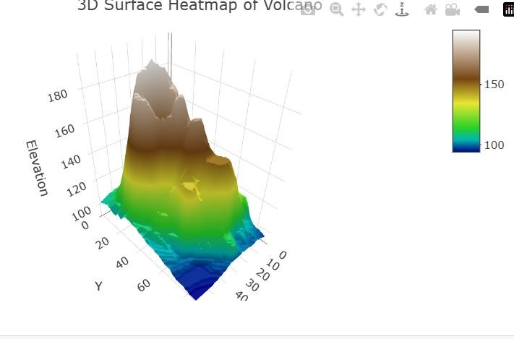
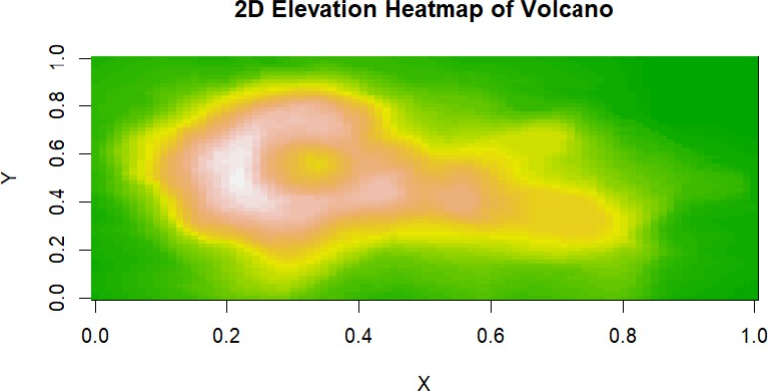
The 3D surface shows the height, peaks and slopes of the volcano more clearly. The 2D heatmap provides a top-down view and makes high- and low-elevation regions easy to compare, but it does not show the terrain shape as clearly.

Result
The elevation data were successfully converted into a 2D grid and visualized using both 3D Plotly surface visualization and a 2D heatmap.

